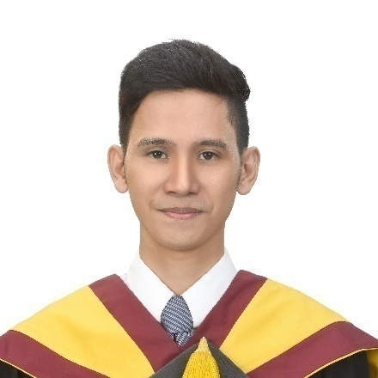Filbert Vincent G. Cañares

|  |  |
| --- | --- |
|  | 320, Purok Blue Marlin, Tungkop Minglanilla,  Cebu 6046 PHILIPPINES |
|  | [filcan427@gmail.com](mailto:filcan427@gmail.com) |  | +63 932 732 9627 |

|  |
| --- |
| **OBJECTIVE** |

|  |
| --- |
| To be employed and help to achieve the goals of the company where my education, qualifications and acquired skills will be utilized to their best to improve the company’s overall performance. |

|  |
| --- |
| **PERSONAL INFORMATION** |

|  |  |
| --- | --- |
| Birthdate  Birthplace  Age  Gender Civil Status  Citizenship Religion | : April 27, 1993  : Cebu City : 25 : Male : Single : Filipino : Roman Catholic |

|  |
| --- |
| **QUALIFICATIONS** |

|  |  |  |
| --- | --- | --- |
| Programming Languages  Software Application  Databases  Web Graphic Design  Hardware  Other Qualifications | :  :  :  :  :  :  :  : | C, C++, C#, SQL and JavaScript  MS Office, Android Studio, Eclipse, Visual Studio, MikroC Access, MySQL, MS SQL Server HTML, Bootstrap, JQuery, Node JS Photoshop, Illustrator, AUTOCAD PC troubleshooting, Network troubleshooting, PIC Microcontroller Can work alone or as a team, Hardworking and Creative |

|  |
| --- |
| **EDUCATIONAL BACKGROUND** |

|  |  |  |
| --- | --- | --- |
| **Tertiary Education** | | |
| 2013 – 2017 |  | Cebu Institute of Technology – University  N. Bacalso Ave., Cebu City  Bachelor of Science in Computer Engineering **(Graduated)** |
| 2011 – 2013 |  | Asian College of Technology  P. del Rosario, Cebu City  Bachelor of Science in Computer Engineering |
| 2009 – 2010 |  | Asian College of Technology  P. del Rosario, Cebu City  Bachelor of Science in Information Technology |
| **Secondary Education** | | |
| 2007 – 2009 |  | St. Paul College Foundation, Inc.  Bulacao, Cebu City |
| 2005 – 2007 |  | Immaculate Heart of Mary Academy  Minglanilla, Cebu |
| **Elementary Education** | | |
| 1999 – 2005 |  | Tungkop Elementary School  Tungkop, Minglanilla, Cebu |

|  |
| --- |
| **AFFILIATION** |

|  |  |  |
| --- | --- | --- |
| **Member**  2015 – 2017 |  | Institute of Computer Engineering of the Philippines (ICpEP)  Cebu Institute of Technology – University |

|  |
| --- |
| **WORK EXPERIENCE** |

|  |  |
| --- | --- |
| **Software Developer**  February 2018 – Present | M. Lhuillier Financial Services Inc.  M. Lhuillier MIS Extension Office, 6000 Cebu |
| **Programmer** (Part Time)  **July 2017 – December 2017** | EKAJ Construction & Design Services  745 Acacia St., Tungkop Minganilla, 6046 Cebu |
| **On-The-Job Trainee**  March 2016 – May 2016 | Teksource Computer Systems Corp.  2nd Level, Elcor Building, Sanciangko Street, Cebu City |

|  |
| --- |
| **REFERENCES** |

|  |
| --- |
| **Engr. Roel B. Lauron**  Chairman – CPE Department  Cebu Institute of Technology – University  Natalio B. Bacalso Ave, Cebu City, 6000 Cebu  (+63)917-311-8450  **Leopoldo “Jake” V. Cabalan, Jr.**  General Manager  EKAJ Construction & Design Services  745 Acacia St., Tungkop Minganilla, 6046 Cebu  (+63)922-732-3639  **Jayrek R. Tabasa**  Android Developer  M. Lhuillier Financial Services Inc.  M. Lhuillier MIS Extension Office, 6000 Cebu  (+63)930-570-4438 |